**COMPUTER GRAPHICS**

1. **Write a program to implement Bresenham’s line drawing algorithm.**

#include <cmath>

#include <cstdlib>

#include <graphics.h>

#include <iostream>

using namespace std;

void bresenhamLine(int x0, int y0, int x1, int y1, int val)

{

if (x0 == x1 && y0 == y1)

{

putpixel(x1, y1, val);

}

else

{

int dx = x1 - x0;

int dy = y1 - y0;

float m = float(dy) / (float)(dx);

if (m >= 1 || m <= 0)

{

cout << "ERROR: Slope must be between 0 and 1." << endl;

exit(1);

}

int d = 2 * dy - dx;

int del_E = 2 * dy;

int del_NE = 2 * (dy - dx);

int x = x0;

int y = y0;

putpixel(x, y, val);

while (x < x1)

{

if (d <= 0)

{

d += del_E;

x += 1;

}

else

{

d += del_NE;

x += 1;

y += 1;

}

putpixel(x, y, val);

}

}

return;

}

int main(void)

{

int x0, y0, x1, y1;

cout << "Enter Left Endpoint (x0 y0): ";

cin >> x0 >> y0;

cout << "Enter Right Endpoint (x1 y1): ";

cin >> x1 >> y1;

cout << "Drawing Line..." << endl;

int gd = DETECT, gm;

initgraph(&gd, &gm, NULL);

bresenhamLine(x0, y0, x1, y1, WHITE);

delay(5e3); //5000

closegraph();

cout << "Finished..." << endl;

return 0;

}

**Output:-**

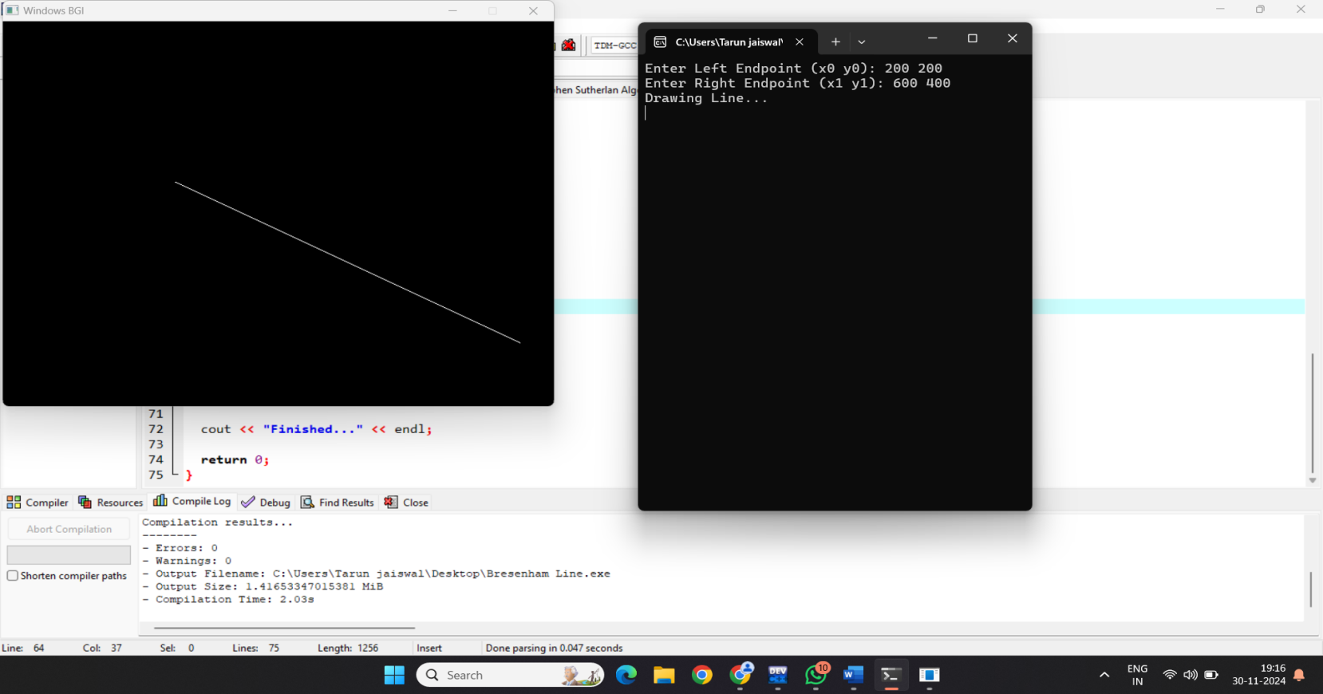

1. **Write a program to implement a midpoint circle drawing algorithm.**

#include <iostream>

#include <graphics.h>

using namespace std;

int main(){

int c,r,xc,yc;

cout<<"Enter the centre coordinates of the circle = "<<endl;

cin>>xc>>yc;

cout<<"Enter radius of the circle = "<<endl;

cin>>r;

int x = 0;

int y = r;

int p = 1-r;

int gd = DETECT, gMode;

initgraph(&gd,&gMode, NULL);

do{

putpixel(x+xc, y+yc,4);

putpixel(xc+x, yc-y,4);

putpixel(xc-x, yc-y,4);

putpixel(xc+y, yc+x,4);

putpixel(xc+y, yc-x,4);

putpixel(xc-x, yc+y,4);

putpixel(xc-y, yc+x,4);

putpixel(xc-y, yc-x,4);

if(p<0){

x =x+1;

p = p+2*x+1;

putpixel(x+xc, y+yc,4);

}

else{

x = x+1;

y = y-1;

p = p+2*x-2*y+1;

putpixel(x+xc, y+yc, 4);

}

}while(x<=y);

delay(10000);

return 0;

}

**OUTPUT:-**

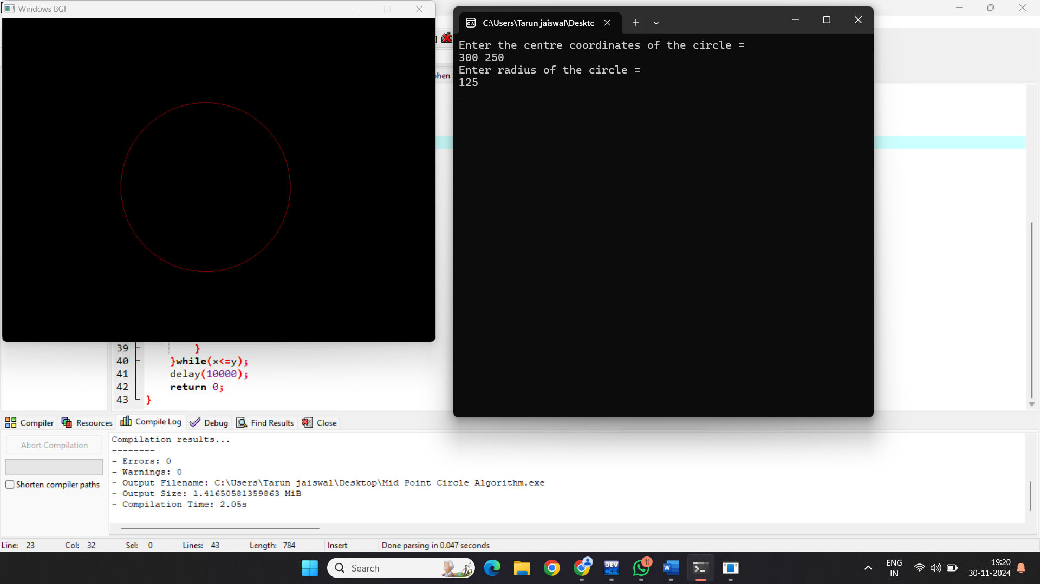

1. **Write a program to clip a line using Cohen and Sutherland line clipping algorithm.**

#include <iostream>

#include <graphics.h>

using namespace std;

int xmin = 100, ymin = 300, xmax = 500, ymax = 500;

const int Left = 1;

const int Right = 2;

const int Top = 8;

const int Bottom = 4;

int computecode (int x, int y) {

int code = 0;

if (x < xmin) code |= Left;

if (y < ymin) code |= Bottom;

if (x > xmax) code |= Right;

if (y > ymax) code |= Top;

return code;

}

void clip (int x0, int x1, int y0, int y1) {

int code1, code2;

int accept, flag = 0;

code1 = computecode(x0, y0);

code2 = computecode(x1, y1);

double m = (y1 - y0) / (x1 - x0);

if ((code1 & code2) != 0) {

accept = false;

} else {

do {

if (code1 == 0 && code2 == 0) {

accept = true;

flag = 1;

} else {

int x, y, temp;

if (code1 == 0) temp = code2;

else temp=code1;

if (temp & Top) {

x= x0 + (1 / m) * (ymax - y0);

y = ymax;

} else if(temp & Bottom) {

x = x0 + (1 / m) * (ymin - y0);

y = ymin;

} else if(temp & Left){

y = y0 + m * (xmin - x0);

x = xmin;

} else if(temp & Right) {

y = y0 + m * (xmax - x0);

x = xmax;

}

if (temp == code1) {

x0 = x;

y0 = y;

code1 = computecode(x0, y0);

} else {

x1 = x;

y1 = y;

code2 = computecode(x1, y1);

}

}

}while(!flag);// do-while end

}

if (accept) {

cleardevice();

line(x0, y0, x1, y1);

rectangle(xmin, ymin, xmax, ymax);

}

}

int main(){

int window1 = initwindow(800, 800);

int x0, x1, y0, y1;

cout << "Enter the co-ordinate of first point: ";

cin >> x0 >> y0;

cout << "Enter the co-ordinate of second point: ";

cin >> x1 >> y1;

line(x0, y0, x1, y1);

rectangle(xmin, ymin, xmax, ymax);

delay(7000);

clip(x0, x1, y0, y1);

system("pause");

return 0;

}

**Output:-**

**Before Cliping:-**

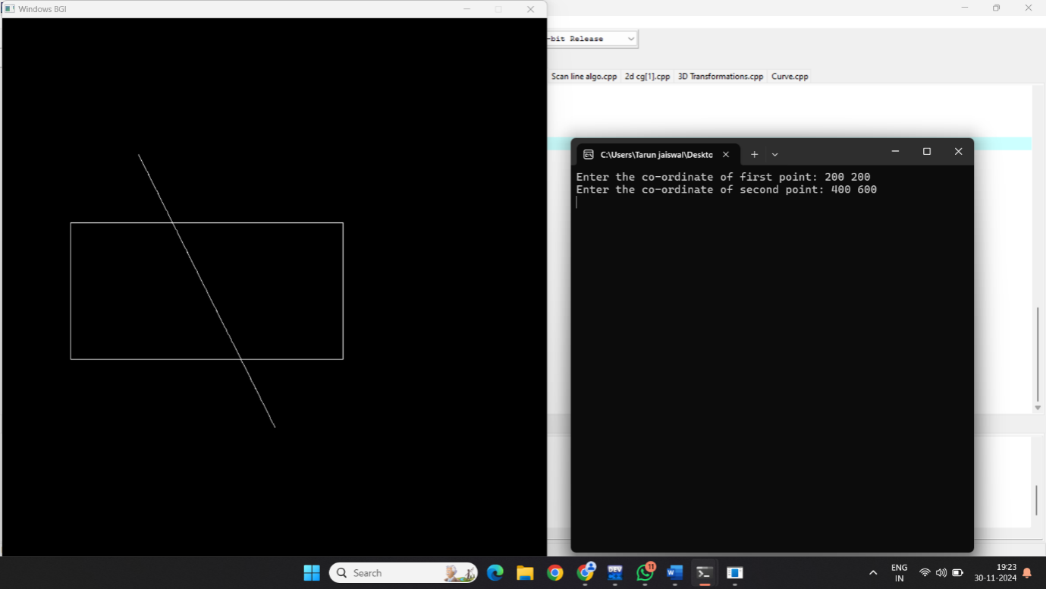

**After Cliping:-**

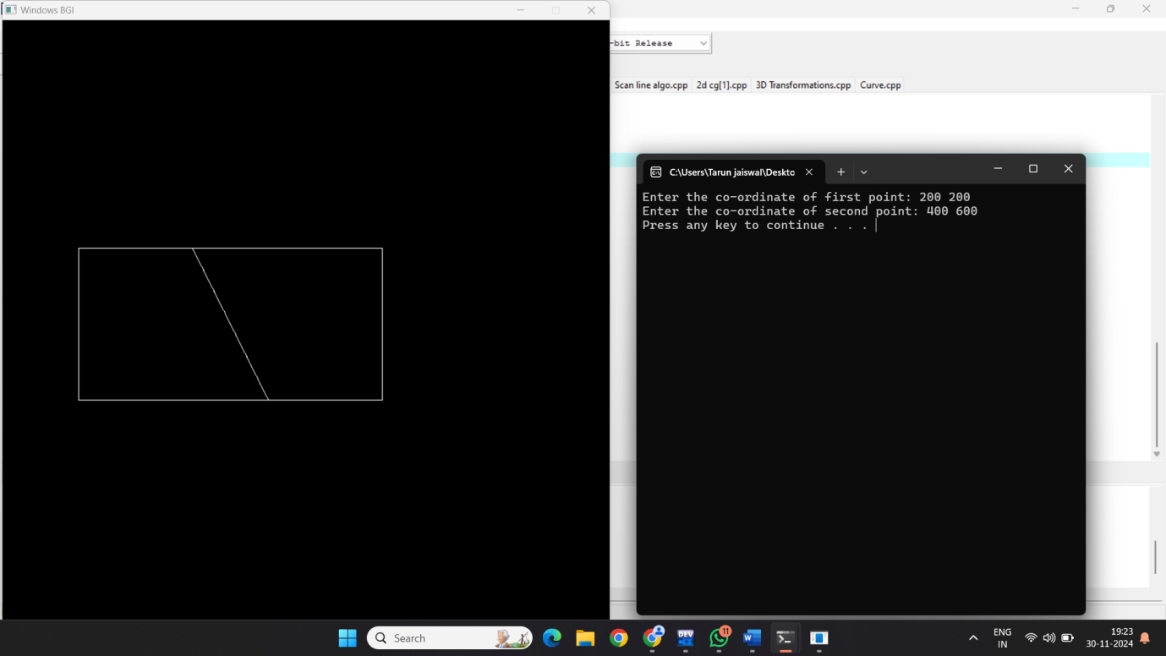

**4. Write a program to clip a polygon using Sutherland Hodgemann algorithm.**

#include <iostream>

#include <graphics.h>

using namespace std;

int xmin = 100, xmax = 500, ymin = 100, ymax = 500, arr[20], m;

int k;

void clipLeft(int x1, int y1, int x2, int y2) {

if (x2 - x1) {

m = (y2 - y1)/(x2 - x1);

}

else {

m = 10000;

}

if (x1 >= xmin && x2 >= xmin) {

arr[k] = x2;

arr[k+1] = y2;

k += 2;

}

if (x1 < xmin && x2 >= xmin) {

arr[k] = xmin;

arr[k+1] = y1 + m*(xmin - x1);

arr[k+2] = x2;

arr[k+3] = y2;

k+=4;

}

if (x1 >= xmin && x2 < xmin) {

arr[k] = xmin;

arr[k+1] = y1 + m*(xmin - x1);

k += 2;

}

}

void clipTop(int x1, int y1, int x2, int y2) {

if (y2 - y1) {

m = (x2 - x1)/(y2 - y1);

}

else {

m = 10000;

}

if (y1<=ymax && y2 <= ymax) {

arr[k] = x2;

arr[k+1] = y2;

k += 2;

}

if (y1 > ymax && y2 <= ymax) {

arr[k] = x1 + m*(ymax - y1);

arr[k+1] = ymax;

arr[k+2] = x2;

arr[k+3] = y2;

k += 4;

}

if (y1 <= ymax && y2 > ymax) {

arr[k] = x1 + m * (ymax - y1);

arr[k+1] = ymax;

k += 2;

}

}

void clipRight(int x1, int y1, int x2, int y2){

if(x2-x1){

m = (y2-y1)/(x2 -x1);

}

else{

m = 10000;

}

if(x1<=xmax && x2<= xmax){

arr[k] = x2;

arr[k+1]= y2;

k +=2;

}

if(x1>xmax && x2<=xmax){

arr[k]= xmax;

arr[k+1]= y1+m*(xmax-x1);

arr[k+2] = x2;

arr[k+3] = y2;

k +=4;

}

if(x1<=xmax && x2>xmax){

arr[k] = xmax;

arr[k+1] = y1 + m*(xmax- x1);

k +=2;

}

}

void clipBottom(int x1, int y1, int x2, int y2){

if(y2-y1){

m = (x2-x1)/(y2-y1);

}

else{

m = 10000;

}

if (y1>=ymin && y2 >= ymin) {

arr[k] = x2;

arr[k+1] = y2;

k += 2;

}

if (y1 >= ymin && y2 >= ymin) {

arr[k] = x1 + m*(ymin - y1);

arr[k+1] = ymin;

arr[k+2] = x2;

arr[k+3] = y2;

k += 4;

}

if (y1 >= ymax && y2 < ymin) {

arr[k] = x1 + m * (ymin - y1);

arr[k+1] = ymin;

k += 2;

}

}

int main() {

int poly[20];

int window1 = initwindow(800, 800);

int n, i;

cout << "Enter the number of edges: " << endl;

cin >> n;

cout << "Enter the coordinates: " << endl;

for (i = 0; i < 2 * n; i++)

cin>>poly[i];

poly[i] = poly[0];

poly[i+1] = poly[1];

rectangle(xmin, ymax, xmax, ymin);

fillpoly(n , poly);

delay(1000);

cleardevice();

k = 0;

for(i =0; i<2*n; i +=2)

clipLeft(poly[i], poly[i+1], poly[i+2], poly[i+3]);

n = k/2;

for(i = 0; i <k; i++)

poly[i]= arr[i];

poly[i]= poly[0];

poly[i+1]= poly[1];

k = 0;

for(int i =0; i<2*n; i +=2)

clipRight(poly[i], poly[i+1], poly[i+2], poly[i+3]);

n = k/2;

for(int i = 0; i <k; i++)

poly[i]= arr[i];

poly[i]= poly[0];

poly[i+1]= poly[1];

k = 0;

for(int i =0; i<2*n; i +=2)

clipBottom(poly[i], poly[i+1], poly[i+2], poly[i+3]);

for(int i = 0; i <k; i++)

poly[i]= arr[i];

rectangle(xmin, ymax, xmax, ymin);

if(k)

fillpoly(k/2,poly);

system("pause");

return 0;

}

**OUTPUT:-**

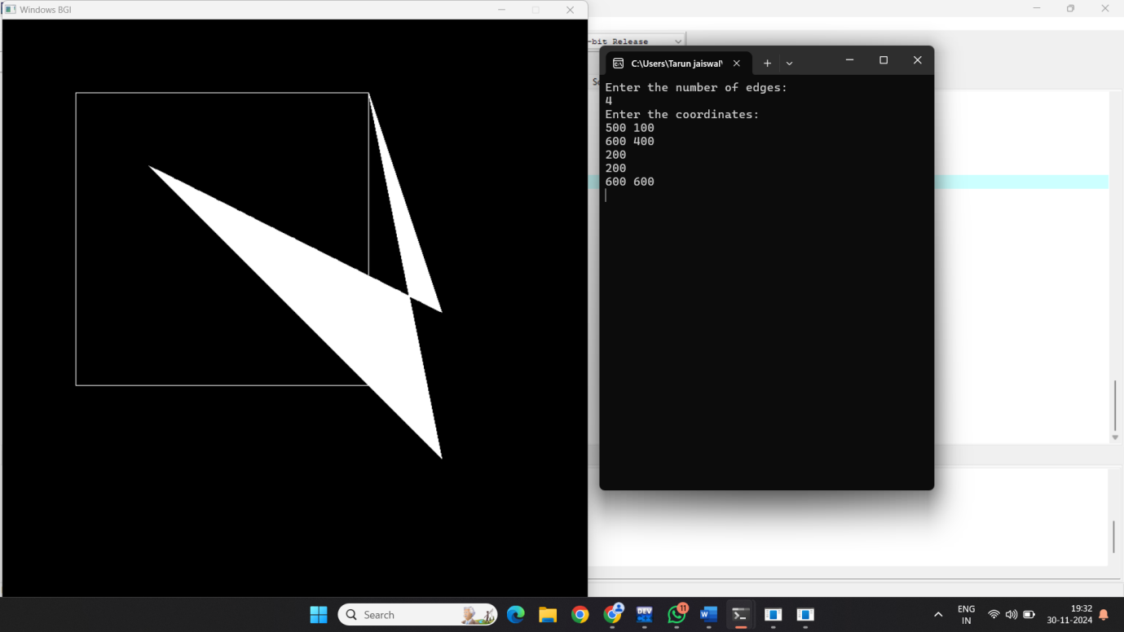

**5. Write a program to fill a polygon using the Scan line fill algorithm.**

#include <graphics.h>

#include <iostream>

using namespace std;

int main()

{

int n, i, j, k, gd, gm, dy, dx;

int x, y, temp;

int a[20][2], xi[20];

float slope[20];

int temp1 = 0;

cout << "\nEnter the number of edges ";

cin >> n;

for (i = 0; i < n; i++)

{

cout << "Enter the coordinate x" << i + 1 << " ";

cin >> a[i][0];

cout << "Enter the coordinate y" << i + 1 << " ";

cin >> a[i][1];

}

a[n][0] = a[0][0];

a[n][1] = a[0][1];

initgraph(&gd, &gm, NULL);

setcolor(YELLOW);

for (i = 0; i < n; i++)

{

line(a[i][0], a[i][1], a[i + 1][0], a[i + 1][1]);

}

for (i = 0; i < n; i++)

{

dy = a[i + 1][1] - a[i][1];

dx = a[i + 1][0] - a[i][0];

if (dy == 0)

slope[i] = 1.0;

if (dx == 0)

slope[i] = 0.0;

if ((dy != 0) && (dx != 0))

{

slope[i] = (float)dx / dy;

}

}

for (y = 0; y < 400; y++)

{

k = 0;

for (i = 0; i < n; i++)

{

if (((a[i][1] <= y) && (a[i + 1][1] > y)) || ((a[i][1] > y) && (a[i + 1][1] <= y)))

{

xi[k] = (int)(a[i][0] + slope[i] * (y - a[i][1]));

k++;

}

}

for (j = 0; j < k; j++)

for (i = 0; i < k; i++)

{

if (xi[i] > xi[i + 1])

{

temp = xi[i];

xi[i] = xi[i + 1];

xi[i + 1] = temp;

}

}

setcolor(YELLOW);

for (i = 0; i < k; i += 2)

{

line(xi[i], y, xi[i + 1] + 1, y);

temp1 = i;

}

}

delay(7000);

return 0;

}

**Output:-**

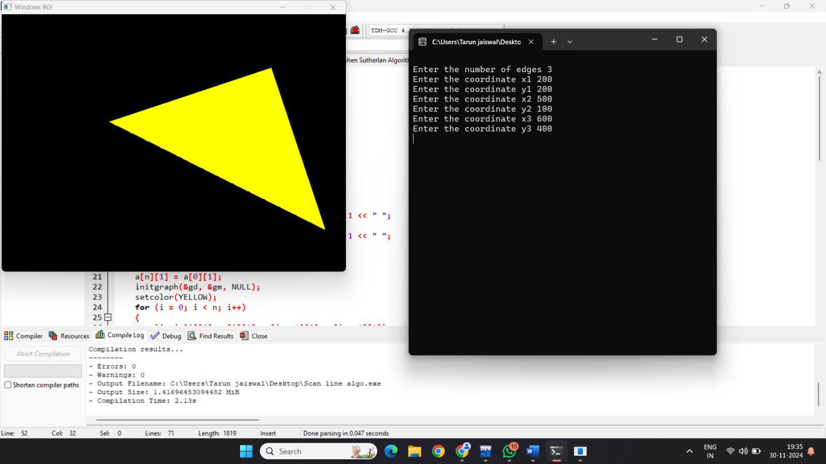

**6. Write a program to apply various 2D transformations on a 2D object (use homogeneous Coordinates).**

#include <iostream>

#include <graphics.h>

#include<cmath>

using namespace std;

int main(){

int tx=2,ty=5;

int window1= initwindow(800,800);

int i,j,k;

float P[2][3];

cout<<"Enter the coordinates of line"<<endl;

for(i=0;i<2;i++){

for(j=0;j<2;j++)

cin>>P[i][j];

P[i][j]=1;

line(P[0][0], P[0][1], P[1][0], P[1][1]);

delay(7000);

float pp[2][3]={0};

int ch;

cout<<"Enter the 2d-transformation"<<endl;

cout<<"1.translation \n 2. shearing \n 3.reflection \n 4.rotation \n S.scaling \n 6.exit"<<endl;

cin>>ch;

switch(ch){

case 1: {

cout<<"Enter the translating factor"<<endl;

cin>>tx>>ty;

int T[3][3]= {{1,0,0},{0,1,0},{tx,ty,1} };

for(i=0;i<2;i++){

for(j=0;j<3;j++)

for(k=0;k<3;k++)

pp[i][j]+=P[i][k]*T[k][j];

line(pp[0][0], pp[0][1], pp[1][0], pp[1][1]);

system("pause");

break; }

}

case 2:

int sh;

char ax;

cout<<"Enter the shearing axis"<<endl;

cin>>ax;

cout<<"Enter the shearing factor"<<endl;

if(ax=='x'){

cin>>sh;

int T[3][3]={{1,0,0},{sh,1,0},{0,0,1}};

for(i-0;i<2;i++){

for(j-0;j<3;j++)

for(k=0;k<3;k++)

pp[i][j]+=P[i][k]*T[k][j];}

line(pp[0][0], pp[0][1],pp[1][0], pp[1][1]);

system("pause");}

if(ax=='y'){

cin>>sh;

int T[3][3]={{1,sh,0},{0,1,0},{0,0, 1}};

for(i=0;i<2;i++){

for(j=0;j<3;j++)

for(k=0;k<3;k++)

pp[i][j]+=P[i][k]*T[k][j];

line(pp[0][0], pp[0][1], pp[1][0], pp[1][1]);

system("pause"); }

break; }

case 3:{

int midx,midy, xn1,yn1,xn2,yn2;

char ax;

midx=getmaxx() /2;

midy=getmaxy() /2;

line(0,midy,midx *2,midy);

line(midx,0,midx,midy*2);

cout<<"Enter the axis for reflection"<<endl;

cin>>ax;

if(ax=='y') {

xn1=(midx-P[1][0])+midx;

yn1=P[0][1];

xn2=(midx-P[0][0])+midx;

yn2=P[1][1]; }

if(ax=='x') {

yn1=(midy-P[1][1])-+midy;

xn1=P[0][0];

yn2=(midy-P[0][1 ])+midy;

xn2=P[1][0];

cout<<xn1<<" "<<yn1<<""<<xn2<<" "<<yn2<<endl;

line(xn1,yn1,xn2,yn2);

system("pause");}

break; }

case 4: {

float theta;

cout<<"Enter the theta for rotation"<<endl;

cin>>theta;

float rx;

rx=(theta*3.14)/180;

float T[3][3]={{cos(rx),sin(rx),0},{-sin(rx),cos(rx),0},{0,0,1}};

for(i-0;i<2;i++){

for(j-0;j<3;j++)

for(k=0;k<3;k++)

pp[i][j]+=P[i][k]*T[k][j];

line(pp[0][0],pp[0][1],pp[1][0],pp[1][1]);

system("pause");}

break; }

case 5:

int Sx,Sy;

cout<<"Enter the scaling factor for x-axis"<<endl;

cin>>Sx;

cout<<"Enter the scaling factor for y -axis"<<endl;

cin>>Sy;

int T[3][3]={{Sx,0,1},{0,Sy,1 },{0,0, 1}};

for(i=0;i<2;i++){

for(j=0;j<3;j++)

for(k=0;k<3;k++)

pp[i][j]+=P[i][k]*T[k][j]; }

line(pp[0][0],pp[0][1],pp[1][0],pp[1][1]);

system("pause");

break;

}}

return 0;}

**Output:-**

**Before:-**

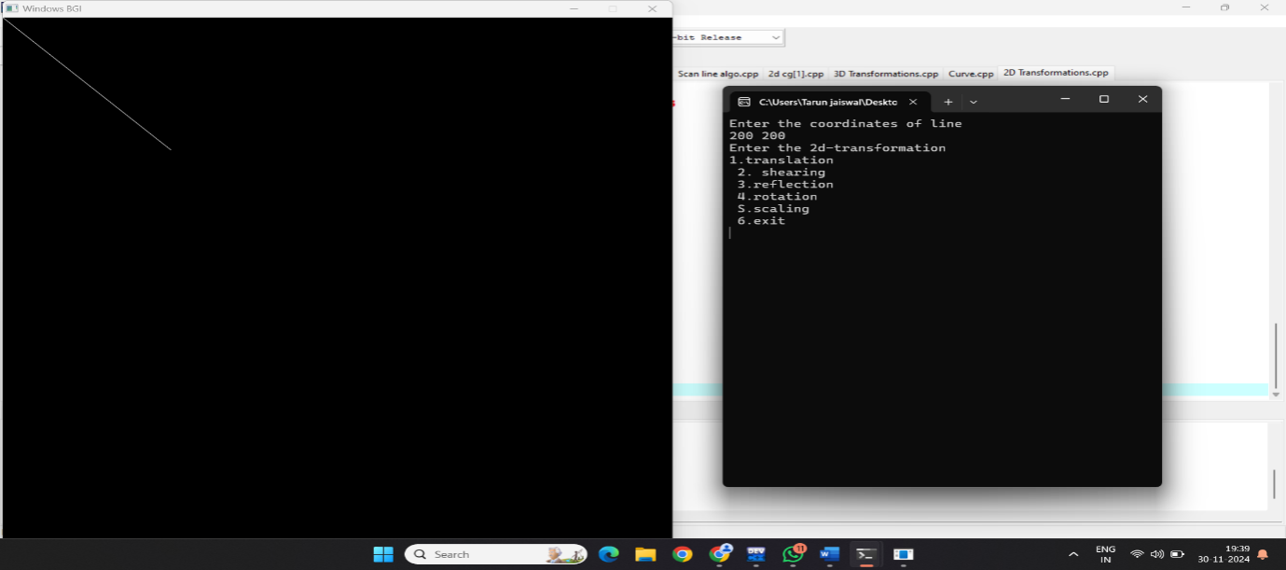

**After:-**

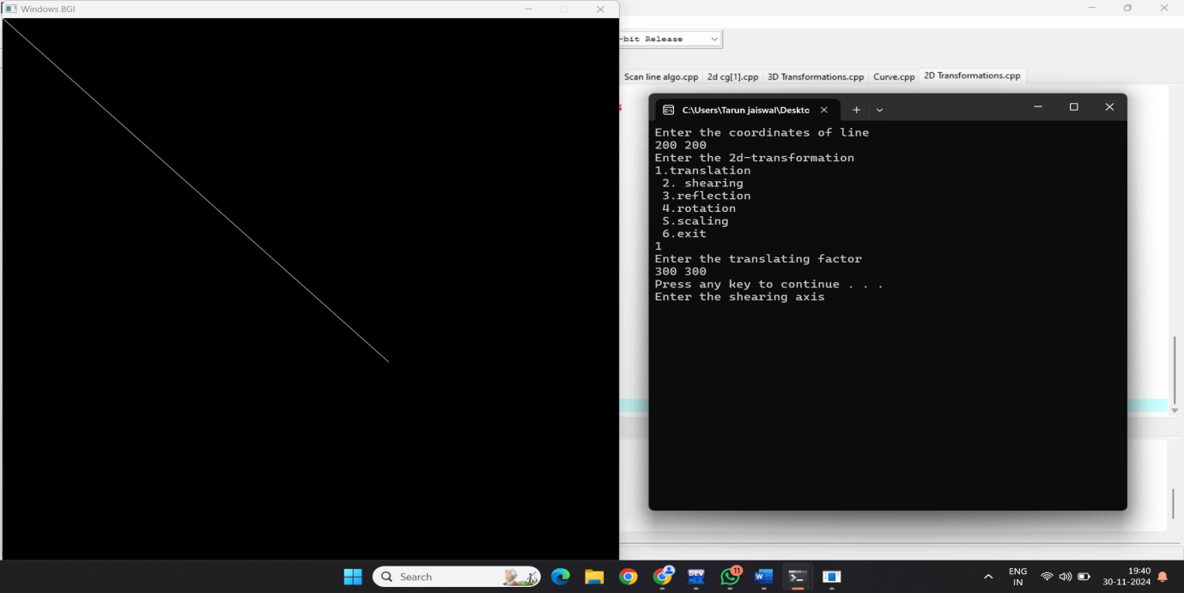

**7. Write a program to apply various 3D transformations on a 3D object and then apply parallel and perspective projection on it.**

#include<iostream>

#include<graphics.h>

#include<cmath>

using namespace std;

int main(){

int window1 = initwindow(800,800);

bar3d(270,200,370,300,50,5);

int ch,i,j,k;

cout<<"Select Your Choice for 3d Transformation\n";

cout<<"1.Translate\n2.Scale\n3.Rotation along x-axis\n4.shearing\n";

cin>>ch;

cleardevice();

switch(ch){

case 1:{

int tx,ty;

cout<<"Enter the translation factor for x,y axis"<<endl;

cin>>tx>>ty;

bar3d(270+tx,200+ty,370+tx,300+ty,50,5);

delay(7000);

cleardevice();

outtextxy(10,20,"Parallel projection side view");

bar3d(0,200+ty,0,300+ty,50,5);

delay(7000);

delay(7000);

break;

}

case 2:{

int sx,sy;

cout<<"Enter the scaling factor for x,y axis"<<endl;

cin>>sx>>sy;

bar3d(270*sx,200*sy,370*sx,300*sy,50,5);

delay(7000);

cleardevice();

outtextxy(10,20,"Parallel projection side view");

bar3d(0,200*sy,0,300*sy,50,5);

delay(7000);

break;

}

case 4:{

int shx,shy;

cout<<"Enter the shearing factor for x,y axis"<<endl;

cin>>shx>>shy;

bar3d(270,200+(shy*270),370,300+(shy*50),50+(270*shx),5);

delay(7000);

break;

}

case 3:{

int ang;

cout<<"Enter the rotation angle"<<endl;

cin>>ang;

ang=(ang*3.14)/180;

int x1= 200*cos(ang)-50*sin(ang);

int y1= 50*cos(ang)+200*sin(ang);

int x2=300*cos(ang)-500*sin(ang);

int y2= 50*cos(ang)+300*sin(ang);

bar3d(x1,y1,x2,y2,50,5);

delay(7000);

break;

}

}

return 0;

}

**Output:-**

**Before Transformation:-**

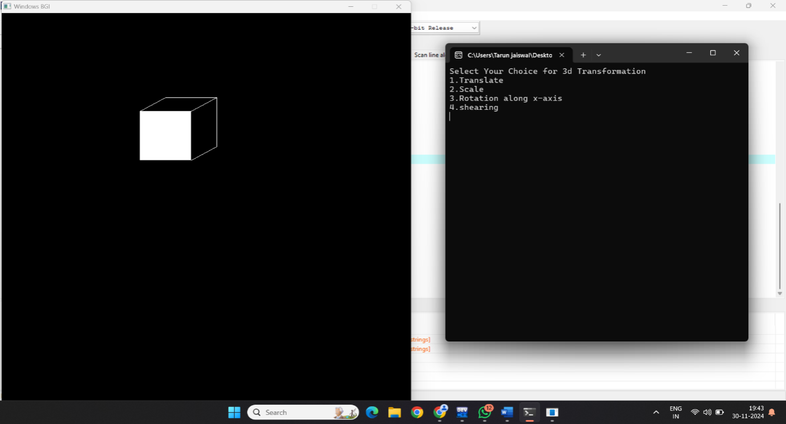

**After Transformation:-**

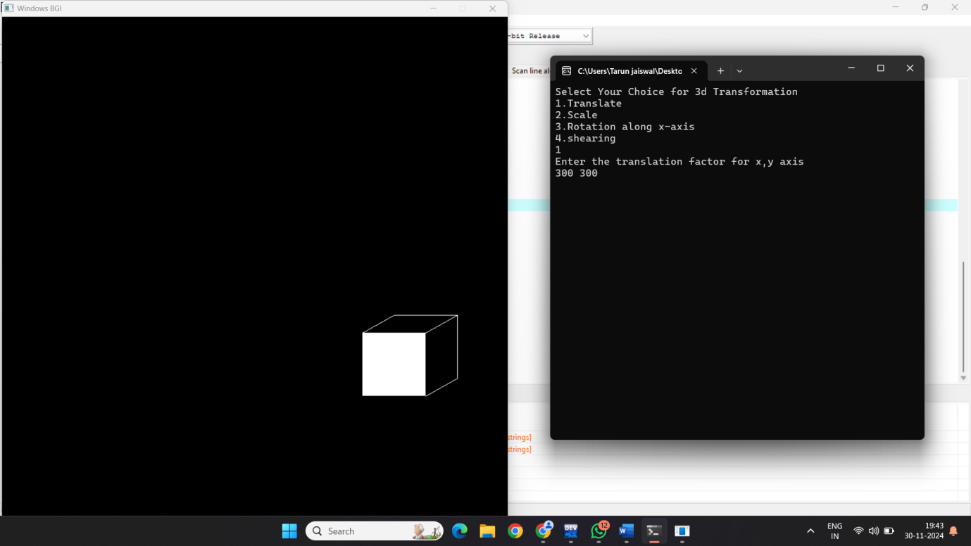

**8. Write a program to draw Hermite /Bezier curve.**

#include<iostream>

#include<graphics.h>

#include<cmath>

using namespace std;

int main(){

int i;

double t,xt,yt;

int window1 = initwindow(800,800);

int ch;

cout<<"Enter the 1 for Bezier Curve and 2 for hermite curve"<<endl;

cin>>ch;

switch(ch){

case 1:{

int x[4]={400,300,400,450};

int y[4]={400,350,275,300};

outtextxy(50,50,"Bezier Curve");

for(t=0;t<=1;t=t+0.0005){

xt = pow(1-t,3)*x[0]+3*t*pow(1-t,2)*x[1]+3*pow(t,2)*(1-t)*x[2]+pow(t,3)*x[3];

yt = pow(1-t,3)*y[0]+3*t*pow(1-t,2)*y[1]+3*pow(t,2)*(1-t)*y[2]+pow(t,3)*y[3];

putpixel (xt, yt,WHITE);}

for (i=0; i<4; i++){

putpixel (x[i], y[i], YELLOW);

delay(4000);}

break;}

case 2:{

int x1[4]={200,100,200,250};

int y1[4]={200,150,75,100};

outtextxy(50,50,"Hermite Curve");

for(t=0;t<=1;t=t+0.00001){

xt=x1[0]*(2*pow(t,3)-(3*t*t)+1)+x1[1]*(-2*pow(t,3)+(3*t*t))+x1[2]*(pow(t,3)-(2*t*t)+t)+x1[3]*(pow(t,3)-(t*t));

yt=y1[0]*(2*pow(t,3)-(3*t*t)+1)+y1[1]*(-2*pow(t,3)+(3*t*t))+y1[2]*(pow(t,3)-(2*t*t)+t)+y1[3]*(pow(t,3)-(t*t));

putpixel (xt, yt,WHITE);}

for (i=0; i<4; i++){

putpixel (x1[i], y1[i], YELLOW);

delay(9000);}

break;}

}

return 0;

}

**Output:-**

